**UNIT I**

Data Science Overview, Evolution of Data Science, Data Science Roles, Tools for Data Science, Applications of Data Science

Data Science Process Overview, Defining Goals, Retrieving Data, Data Preparation, Data Exploration, Data Modeling, Presentation

Data Science Ethics, Doing good Data Science, Owners of the Data, Valuing different aspects of Privacy, Getting Informed Consent, The Five Cs of Data Science, Diversity, Inclusion, Future Trends in Data Science.

**DATA SCIENCE OVERVIEW**

**What is Data Science?**

***Data science is the science of analyzing raw data using statistics and machine learning techniques with the purpose of drawing conclusions about that information***

[Data science](https://www.geeksforgeeks.org/what-is-data-science/) is an interdisciplinary field that focuses on extracting knowledge and insights from structured and unstructured data using various scientific methods, processes, algorithms, and systems. Simply put, it's the process of turning raw data into valuable information. It involves using statistics, computer science, and knowledge of the specific area you're working in. Think of it as detective work where you use data to uncover patterns, make predictions, and inform decision-making.

**Key Concepts and Terminologies**

1. **Big Data:** [Big data](https://www.geeksforgeeks.org/what-is-big-data/) refers to extremely large data setsthata cannot be managed or processed using traditional data processing techniques, It encompasses the three ***VS: Volume, Velocity, and Varuiety***.
2. **Machine Learning :**[Machine Learning](https://www.geeksforgeeks.org/ml-machine-learning/) is a subset of artificial intelligence that enables systems to learn from data and improve performance without explicit programming. It involves algorithms such as regression, classification and clustering.
3. **Artificial Intelligence:** [Artificial intelligence](https://www.geeksforgeeks.org/artificial-intelligence-an-introduction/) (AI) is the broader concept of machines being able to carry out tasks in a way that we would consider "smart." AI includes machine learning, natural language processing, and robotics.
4. **Data Mining:** [Data mining](https://www.geeksforgeeks.org/data-mining/) involves discovering patterns and knowledge from large amounts of data. It uses methods at the intersection of machine learning, statistics, and database systems.
5. **Predictive Analytics**: Predictive analytics uses historical data to predict future outcomes. It involves statistical techniques, machine learning algorithms, and data mining.

**EVOLUTION OF DATA SCIENCE**

Data science has evolved from the use of statistics and applied mathematics to a field that uses data to make predictions and drive business decisions. The evolution of data science has been marked by the development of new technologies and the rise of new tools and techniques.

Early developments

* **Statistics**: The use of statistics for data analysis dates back to 800 AD with the work of Iraqi mathematician Al Kindi.
* **Relational databases**: In the 1970s and 1980s, relational databases and SQL (Structured Query Language) allowed for more efficient data storage and retrieval.
* **Business intelligence**: Companies began using data to inform their decision-making processes.

Modern developments

* **Machine learning**

Algorithms can learn from data and make predictions without requiring much coding input.

* **Deep learning**

Neural networks have made breakthroughs in language processing and computer vision.

* **Cloud computing**

Scalable cloud platforms have made data storage and processing more accessible and cost saving.

* **Data visualization**

Data analytics can be made more exciting with the aid of AR and VR.

* **Open-source tools**

Programming languages like S and R, and open-source databases like Hadoop, have revolutionized data science.

**DATA SCIENCE ROLES**

Data science roles include data analysis, artificial intelligence, business intelligence, management, data visualization, programming, and software engineering.

Data analysis

* **Data analyst**: Collects, cleans, and aggregates data. They design reports, data models, and visualizations.
* **Business intelligence analyst**: Builds and updates reports and dashboards.

Artificial intelligence

* **AI engineer**: Creates algorithms and models that integrate machine learning and artificial intelligence.

Data visualization

* **Data scientist**: Uses visualization to detect outliers, validate model assumptions, and identify correlations.

Programming

* **Data scientist**: Writes computer programs and analyzes large datasets. They use programming languages like Java, R, Python, and SQL.

Management

* **Database administrator**: Manages an organization's database to ensure data security, user access, and efficient functioning.

Software engineering

* **Data scientist and software engineer**: Collaborate to create new capabilities for analyzing and processing data.

Exploratory data analysis

* **Data scientist**: Uses statistical techniques and data visualization tools to identify patterns and gain insights from data.

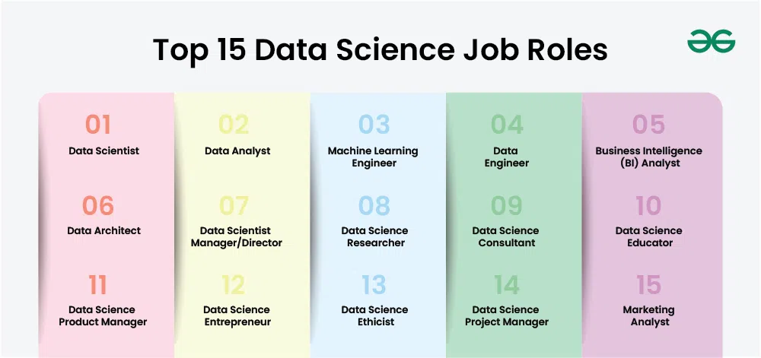

**APPLICATIONS OF DATA SCIENCE**

Data Science plays a crucial role in transforming raw data into actionable insights. Its importance lies in its ability to help organizations make informed decisions, predict trends and improve operational efficiency.

* **Healthcare:** Improving patient care, predicting disease outbreaks, and optimizing treatment plans.
* **Finance:** Fraud detection, risk management, and algorithmic trading.
* **Marketing:** Personalized marketing strategies, customer segmentation, and sentiment analysis.
* **E-commerce:** Recommendation systems, inventory management, and sales forecasting.
* **Transportation:** Route optimization, predictive maintenance, and autonomous driving.

**DATA SCIENCE LIFE-CYCLE**

1. **Data Collection:** The first step in the data science process involves gathering data from various sources, such as databases, APIs, web scraping, and sensors. The quality and quantity of data collected significantly impact the subsequent stages of the process.
2. **Data Cleaning:**Data cleaning, or data preprocessing, involves identifying and correcting errors, handling missing values, and transforming data into a suitable format for analysis. This step ensures the reliability and accuracy of the data.
3. **Data Analysis:**[Data analysis](https://www.geeksforgeeks.org/what-is-data-analysis/) involves applying statistical and computational techniques to explore and understand the data. This step may include descriptive statistics, correlation analysis, and hypothesis testing to uncover patterns and relationships.
4. **Data Visualization:**[Data visualization](https://www.geeksforgeeks.org/data-visualization-and-its-importance/) is the graphical representation of data, making it easier to identify trends and insights. Tools like Matplotlib and Seaborn are commonly used to create visualizations such as bar charts, histograms, and scatter plots.
5. **Data Interpretation:**[Data interpretation](https://www.geeksforgeeks.org/data-interpretation-questions-aptitude/) involves deriving meaningful conclusions from the analysis and visualization results. It requires domain knowledge.

**ESSENTIAL TOOLS AND TECHNOLOGIES:**

**Programming Languages:**

* [**Python**:](https://www.geeksforgeeks.org/history-of-python/) Widely used for its simplicity and extensive libraries for data science.
* [**R**](https://www.geeksforgeeks.org/r-programming-language-introduction/)**:**Popular for statistical analysis and visulaization.

**Data Analysis Tools:**

* [**Pandas**](https://www.geeksforgeeks.org/python-pandas-series/)**:** A Python library for data manipulation and analysis.
* [**NumPy**](https://www.geeksforgeeks.org/python-numpy/)**:** A Python library for numerical computations.

**Machine Learning Libraries:**

* **Scikit-Learn:** A Python library for machine learning, providing simple and efficient tools for data mining and data analysis.
* [**TensorFlow**](https://www.geeksforgeeks.org/introduction-to-tensorflow/)**:** An open-source library for numerical computation and machine learning.

**Visulaization Tools:**

* [**Matplotlib**](https://www.geeksforgeeks.org/python-introduction-matplotlib/)**:** A plotting library for creating static, interactive, and animated visualizations.
* [**Seaborn:**](https://www.geeksforgeeks.org/introduction-to-seaborn-python/) A Python visualization library based on Matplotlib, providing a high-level interface for drawing attractive statistical graphics.

**Database Mangement Systems:**

* [**SQL**](https://www.geeksforgeeks.org/sql-tutorial/)**:**A language for managing and querying relational databases.
* [**NoSQL**](https://www.geeksforgeeks.org/introduction-to-nosql/)**:** Non-relational databases like MongoDB, designed for large-scale data storage and flexible data models.

**CHALLENGES IN DATA SCIENCE:**

1. **Data Privacy and Security**: Ensuring data is protected from unauthorized access and misuse.
2. **Handling Big Data:** Managing and processing large volumes of data effectively.
3. **Model Interpretability:** Making complex models understandable to non-experts.
4. **Keeping Up with Evolving Technologies:**Continuously learning and adapting to new tools and methods.

**FUTURE TRENDS IN DATA SCIENCE:**

1. **AI and Machine Learning Advancements:**Expect more advanced algorithms and greater computing power.
2. **Increased Automation:**Tools that automate data science workflows, making it easier for everyone to use.
3. **Ethical Considerations and Regulations:** Developing guidelines to ensure data is used responsibly and fairly.
4. **Integration with IoT and Edge Computing:**Analyzing data from IoT devices in real-time, enabling smart cities and industrial automation.

**DATA SCIENCE PROCESS OVERVIEW**

**Data Science Life Cycle**

Data science is not a one-step process such that you will get to learn it in a short time and call ourselves a Data Scientist. It’s passes from many stages and every element is important. One should always follow the proper steps to reach the ladder. Every step has its value and it counts in your model.

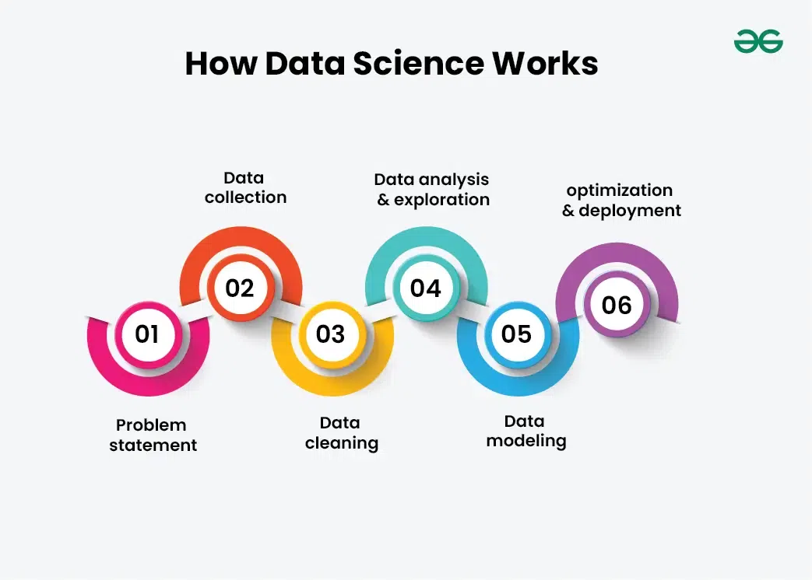

**Problem Statement:**

No work start without motivation, Data science is no exception though. It’s really important to declare or formulate your problem statement very clearly and precisely. Your whole model and it’s working depend on your statement. Many scientist considers this as the main and much important step of Date Science. So make sure what’s your problem statement and how well can it add value to business or any other organization.

**2. Data Collection:**

After defining the problem statement, the next obvious step is to go in search of data that you might require for your model. You must do good research, find all that you need. Data can be in any form i.e unstructured or structured. It might be in various forms like videos, spreadsheets, coded forms, etc. You must collect all these kinds of sources.

**3. Data Cleaning:**

As you have formulated your motive and also you did collect your data, the next step to do is cleaning. Yes, it is! Data cleaning is the most favorite thing for data scientists to do. Data cleaning is all about the removal of missing, redundant, unnecessary and duplicate data from your collection. There are various tools to do so with the help of programming in either R or [Python](https://www.geeksforgeeks.org/python-programming-language/). It’s totally on you to choose one of them. Various scientist have their opinion on which to choose. When it comes to the statistical part, R is preferred over Python, as it has the privilege of more than 12,000 packages. While python is used as it is fast, easily accessible and we can perform the same things as we can in R with the help of various packages.

**4. Data Analysis and Exploration:**

It’s one of the prime things in data science to do and time to get inner Holmes out. It’s about analyzing the structure of data, finding hidden patterns in them, studying behaviors, visualizing the effects of one variable over others and then concluding. We can explore the data with the help of various graphs formed with the help of libraries using any programming language. In R, GGplot is one of the most famous models while Matplotlib in Python.

**5. Data Modelling:**

Once you are done with your study that you have formed from data visualization, you must start building a hypothesis model such that it may yield you a good prediction in future. Here, you must choose a good algorithm that best fit to your model. There different kinds of algorithms from regression to classification, SVM( Support vector machines), Clustering, etc. Your model can be of a [Machine Learning](https://www.geeksforgeeks.org/machine-learning/) algorithm. You train your model with the train data and then test it with test data. There are various methods to do so. One of them is the K-fold method where you split your whole data into two parts, One is Train and the other is test data. On these bases, you train your model.

**6. Optimization and Deployment:**

You followed each and every step and hence build a model that you feel is the best fit. But how can you decide how well your model is performing? This where optimization comes. You test your data and find how well it is performing by checking its accuracy. In short, you check the efficiency of the data model and thus try to optimize it for better accurate prediction. Deployment deals with the launch of your model and let the people outside there to benefit from that.

**ETHICS IN DATA SCIENCE**

**What is Ethics in Data Science?**

Ethics in Data Science refers to the responsible and ethical use of the data throughout the entire data lifecycle. This includes the collection, storage, processing, analysis, and interpretation of various data.

* **Privacy:**It means respecting an individual's data with confidentiality and consent.
* **Transparency:**Communicating how data is collected, processed, and used, So it will maintain transparency.
* **Fairness and Bias:**Ensuring fairness in data-driven processes and addressing biases that may arise in algorithms, preventing discrimination against certain groups.
* **Accountability:**Holding individuals and organizations accountable for their actions and decisions based on data.
* **Security:**Implementing robust security measures sensitive data and protects them from unauthorized access and breaches.
* **Data Quality:**Ensures the accuracy of the data , completeness and the reliability of the data to prevent any misinformation.

**The Importance of Ethical Data Usage**

Data Scientist are the Heart of Data they hold the data which can make powerful decisions that can shape the future. the data is more valuable than anything so maintaining ethical standards is not a obligation but it's a fundamental aspect of a Data scientist ensuring responsible data usage

Ethical Data usage is the main block of trust. When individuals provide their Data to organizations or platforms, they expect it to maintain with integrity and basic ethics. Respecting their privacy is most important part as it will increase the organization reputation.

**THE FIVE C’s OF DATA SCIENCE**

the five Cs: consent, clarity, consistency, control (and transparency), and consequences (and harm). They’re a framework for implementing the golden rule for data. Let’s look at them one at a time.

**Consent**

You can’t establish trust between the people who are providing data and the people who are using it without agreement about what data is being collected and how that data will be used. Agreement starts with obtaining consent to collect and use data. Unfortunately, the agreements between a service’s users (people whose data is collected) and the service itself (which uses the data in many ways) are binary (meaning that you either accept or decline) and lack clarity. In business, when contracts are being negotiated between two parties, there are multiple iterations (redlines) before the contract is settled. But when a user is agreeing to a contract with a data service, you either accept the terms or you don’t get access. It’s non-negotiable.

For example, when you check in to a hospital you are required to sign a form that gives them the right to use your data. Generally, there’s no way to say that your data can be used for some purposes but not others. When you sign up for a loyalty card at your local pharmacy, you’re agreeing that they can use your data in unspecified ways. Those ways certainly include targeted advertising (often phrased as “special offers”), but may also include selling your data (with or without anonymization) to other parties. And what happens to your data when one company buys another and uses data in ways that you didn’t expect?

Data is frequently collected, used, and sold without consent. This includes organizations like Acxiom, Equifax, Experian, and Transunion, who collect data to assess financial risk, but many common brands also connect data without consent. In Europe, [Google collected data](https://techcrunch.com/2014/04/04/google-street-view-fine/) from cameras mounted on cars to develop new mapping products. [AT&T and Comcast](https://www.techdirt.com/articles/20160609/12091134667/consumer-groups-say-att-comcast-violate-privacy-law-hoovering-up-cable-box-data-without-full-user-consent.shtml) both used cable set top boxes to collect data about their users, and [Samsung](https://www.computerworld.com/article/2889456/epic-files-ftc-complaint-about-samsungs-smart-tv-surveillance.html) collected voice recordings from TVs that respond to voice commands. There are many, many more examples of non-consensual data collection. At every step of building a data product, it is essential to ask whether appropriate and necessary consent has been provided.

**Clarity**

Clarity is closely related to consent. You can’t really consent to anything unless you’re told clearly what you’re consenting to. Users must have clarity about what data they are providing, what is going to be done with the data, and any downstream consequences of how their data is used. All too often, explanations of what data is collected or being sold are buried in lengthy legal documents that are rarely read carefully, if at all. Observant readers of Eventbrite’s user agreement [recently discovered that listing an event gave the company the right to send a video team, and exclusive copyright to the recordings](https://arstechnica.com/information-technology/2018/04/eventbrite-rolls-back-policy-that-would-have-given-it-right-to-record-events/). And the only way to opt out was by writing to the company. The backlash was swift once people realized the potential impact, and Eventbrite removed the language.

Facebook users who played Cambridge Analytica’s “This Is Your Digital Life” game may have understood that they were giving up their data; after all, they were answering questions, and those answers certainly went somewhere. But did they understand how that data might be used? Or that they were giving access to their friends’ data behind the scenes? That’s buried deep in Facebook’s privacy settings.

Even when it seems obvious that their data is in a public forum, users frequently don’t understand how that data could be used. Most Twitter users know that their public tweets are, in fact, public; but [many don’t understand that their tweets can be collected and used for research](http://journals.sagepub.com/doi/10.1177/2056305118763366), or even that they are [for sale](https://developer.twitter.com/en/pricing.html). This isn’t to say that such usage is unethical; but as [Casey Fiesler](http://caseyfiesler.com/) points out, the need isn’t just to get consent, but to inform users what they’re consenting to. That’s clarity.

It really doesn’t matter which service you use; you rarely get a simple explanation of what the service is doing with your data, and what consequences their actions might have. Unfortunately, the process of consent is often used to obfuscate the details and implications of what users may be agreeing to. And once data has escaped, there is no recourse. You can’t take it back. Even if an organization is willing to delete the data, it’s very difficult to prove that it has been deleted.

There are some notable exceptions: people like John Wilbanks are [working](http://thegovlab.org/john-wilbanks-improving-informed-consent-through-design-to-advance-science/) to develop models that help users to understand the implications of their choices. Wilbanks’ work helps people understand what happens when they provide [sensitive medical and health data to a service](https://papers.ssrn.com/sol3/papers.cfm?abstract_id=2769129).

**Consistency and trust**

Trust requires consistency over time. You can’t trust someone who is unpredictable. They may have the best intentions, but they may not honor those intentions when you need them to. Or they may interpret their intentions in a strange and unpredictable way. And once broken, rebuilding trust may take a long time. Restoring trust requires a prolonged period of consistent behavior.

Consistency, and therefore trust, can be broken either explicitly or implicitly. An organization that exposes user data can do so intentionally or unintentionally. In the past years, we’ve seen many security incidents in which customer data was stolen: Yahoo!, Target, Anthem, local hospitals, government data, and data brokers like Experian, the list grows longer each day. Failing to safeguard customer data breaks trust—and safeguarding data means nothing if not consistency over time.

We’ve also seen frustration, anger, and surprise when users don’t realize what they’ve agreed to. When Cambridge Analytica used Facebook’s data to target vulnerable customers with highly specific advertisements, Facebook initially claimed that this was not a data breach. And while Facebook was technically correct, in that data was not stolen by an intruder, the public’s perception was clearly different. This was a breach of trust, if not a breach of Facebook’s perimeter. Facebook didn’t consistently enforce its agreement with its customers. When the news broke, Facebook became unpredictable because most of its users had no idea what it would or wouldn’t do. They didn’t understand their user agreements, they didn’t understand their complex privacy settings, and they didn’t understand how Facebook would interpret those settings.

**Control and transparency**

Once you have given your data to a service, you must be able to understand what is happening to your data. Can you control how the service uses your data? For example, Facebook asks for (but doesn’t require) your political views, religious views, and gender preference. What happens if you change your mind about the data you’ve provided? If you decide you’re rather keep your political affiliation quiet, do you know whether Facebook actually deletes that information? Do you know whether Facebook continues to use that information in ad placement?

All too often, users have no effective control over how their data is used. They are given all-or-nothing choices, or a convoluted set of options that make controlling access overwhelming and confusing. It’s often impossible to reduce the amount of data collected, or to have data deleted later.

A major part of the shift in data privacy rights is moving to give users greater control of their data. For example, Europe’s [General Data Protection Regulation](https://en.wikipedia.org/wiki/General_Data_Protection_Regulation) (GDPR) requires a user’s data to be provided to them at their request and removed from the system if they so desire.

**Consequences**

Data products are designed to add value for a particular user or system. As these products increase in sophistication, and have broader societal implications, it is essential to ask whether the data that is being collected could cause harm to an individual or a group. We continue to hear about unforeseen consequences and the “unknown unknowns” about using data and combining data sets. Risks can never be eliminated completely.

**GETTING INFORMED CONSENT IN DATA SCIENCE**

Informed consent is a fundamental ethical principle in data science that requires researchers to obtain permission from participants to collect and use their data. It's a way to ensure that participants are fully aware of what the research involves and can choose to participate voluntarily.

Why is informed consent important?

* **Protects privacy**: Informed consent protects participants' privacy rights by ensuring they're aware of how their data will be used.
* **Builds trust**: Informed consent helps build trust between researchers and participants.
* **Ensures ethical research**: Informed consent is a requirement for ethical research and helps ensure that research is conducted responsibly.

**What should be included in informed consent?**

* The purpose of the research
* What data will be collected
* How the data will be used
* How the data will be stored and shared
* How the participant's anonymity will be protected
* The participant's right to withdraw from the research

When is informed consent required?

* Informed consent is required for all research that involves human participants.
* It's especially important for research that involves sensitive personal data.

**FUTURE TRENDS IN DATA SCIENCE**

**9 emerging trends in data science**

1. TinyML

TinyML refers to implementing machine learning models on tiny, low-power devices like sensors and IoT ([Internet of Things](https://binariks.com/expertise/iot-software-development-services/) ) devices. This trend is significant for edge computing, where data processing occurs close to where it's generated. TinyML is a user-friendly way to process data quickly and competently.

2. Predictive analytics

Want to use data-driven insights for your best benefit? Predictive analytics is your best bet for an impeccable marketing strategy. Predictive analytics highlights the increasing use of machine learning and statistical models to predict future outcomes based on historical data.

For those wanting to anticipate market trends and potential consumer behavior, this is a data science trend to adopt in 2025. Risk assessment also benefited tremendously from [predictive analytics](https://binariks.com/blog/predictive-analytics-in-fintech/) .

Predictive analytics relies heavily on the availability of[big data](https://binariks.com/expertise/big-data-analytics-services/) . Today, we have more efficient data processing tools capable of handling large volumes of data at incredible speeds, data visualization tools, and cloud computing, which are constantly developing.

3. AutoML

Automated machine learning is one of the new trends in data science. AutoML streamlines and automates the process of applying machine learning models. In this way, it becomes more available to non-experts and more efficient, leading to the democratization of data science.

Essentially, AutoML is ML plus automation and application to real-life problems. With this data science trend, professionals whose primary expertise is not ML have access to ML. The [development of ML-based apps](https://binariks.com/services/ai-ml-development-services/) heavily relies on automated machine learning.

4. Cloud migration

In 2025, no tool for data storage is more scalable, flexible, and cost-effective than a[cloud](https://binariks.com/expertise/cloud-development-services/) . Surprisingly, data migration is also quite budget-friendly, as there is no need to invest in additional physical infrastructure.

Therefore, approximately 44% of traditional small businesses utilize cloud infrastructure or hosting services. In contrast, this adoption is higher among small tech companies, with 66% leveraging these services. Enterprises show the highest adoption rate at 74%, and the numbers are only expected to grow ([Source](https://www.cloudzero.com/blog/cloud-computing-statistics/#:~:text) ).

Right now, the cloud migration market is one of the data science trends that is impossible not to notice. It is currently worth USD 232.51 billion and is projected to grow at a (CAGR) of 28.24% and reach 806.41 billion by 2029 ([Source](https://www.mordorintelligence.com/industry-reports/cloud-migration-services-market) ).

5. Cloud-native

Cloud-native solutions are designed for cloud-computing environments. They are used to develop services packaged in containers. Unlike cloud migration, which refers to migrating data to the cloud, cloud-native technologies are designed for cloud environments.

Examples of these include microservices, containerization, and dynamic orchestration. Cloud-native technologies are one of the data science trends that participate in scalability and lead to faster development and deployment cycles. They are managed by DevOps technologies. Cloud-native technologies are one of the most popular trends in data science because they are cheaper than building on-premise infrastructure.

6. Augmented consumer interface

This data science trend refers to advanced, data-driven interfaces that enhance user experience through personalization and interactivity. AI and machine learning are both significant tools in creating augmented consumer interfaces.

Moreover, they are prone to using [IoT](https://binariks.com/blog/ai-iot-use-cases-and-benefits/) , [VR](https://binariks.com/blog/virtual-reality-in-digital-therapeutics/) , and AR. These interfaces are expected to transform how we shop and interact, with potential applications in virtual reality shopping experiences and communication interfaces like Brain-Computer Interfaces (BCI)​.

An example of an augmented consumer interface is a virtual fitting room in an online retail store where customers can create an avatar based on their body measurements and overall looks.

7. Data regulation

In 2025, there is just so much data online that protecting data privacy is the top priority for every business, whatever it might be. This is especially true for [data-sensitive domains like healthcare](https://binariks.com/blog/ai-regulations-in-healthcare-us-eu/) and insurance.

There are several new [data regulation](https://binariks.com/blog/regtech-compliance-solutions/) acts for new companies to watch for in 2025, including:

* State privacy laws in the USA in states including Montana Consumer Data Privacy Act, Florida Digital Bill of Rights, Texas Data Privacy and Security Act, Oregon Consumer Privacy Act, and Delaware Personal Data Privacy Act.
* In 2024, Canada introduced the Consumer Privacy Protection Act (CPPA), the Personal Information and Data Protection Tribunal Act, and the Artificial Intelligence and Data Act (AIDA). You can expect enhanced individual control over personal data and more substantial penalties for non-compliance from these acts.
* In the EU, an ePrivacy Regulation (ePR) finalized in 2024 establishes regulations on cookie usage and apps like WhatsApp and Facebook Messenger.
* AI regulation is entering a pivotal phase in 2025, with the long-awaited AI Act, which is a general EU legislation that brings a category-based approach to different types of artificial intelligence.
* Digital Services Act (DSA) is an upcoming EU regulation that defines legal and harmful content that can be removed from digital platforms.

Naturally, new legislative acts will persuade businesses to audit their current processes in alignment with the new legislation.

8. AI as a Service (AIaaS)

AI as a service is one of the data science industry trends that allows your company to implement newly[emerging AI technologies](https://binariks.com/blog/generative-ai-for-business/) like [OpenAI GPT4](https://binariks.com/blog/chatgpt-for-telemedicine-and-remote-healthcare/) and Google Bard without significant investments. Many of these open-language models make their APIs available to the general public. Businesses can create learning frameworks and chatbots based on the existing language models to cater to their needs.

9. Python's increasing role

Python is the primary programming language for data analytics. If you pursue an engineering job in data science in 2025, this is the language to learn now. Python's role in data science continues to grow due to its versatility and the extensive range of libraries available for data science and machine learning.

Popular examples include Pandas and Scikit-learn. [Python](https://binariks.com/technologies/python/) is attractive because it is also increasingly used in diverse fields beyond its traditional applications, such as 3D game development and bioinformatics.

Aside from the data science future trends that will undeniably rule most industries, some trends are more industry-specific than those due to their specific benefits. Let's focus on the benefits for the domains in which Binariks has immaculate experience.

Medtech (medical technology)

In medicine, the most critical aspect is to make professionals benefit from the technology and make it a tool that assists them in decision-making and makes everything more accurate and fast. However, this is a hanging balance for stakeholders to maintain, as doctors and caretakers should not over-rely on technology.

* **Data democratization**

Data democratization is one of the emerging trends in data science that caters explicitly to medical technology simply because medical establishments have medical and non-medical staff who must be educated about technological advancements for everything to work. Knowledgeable doctors and nurses enhance patient care through informed decision-making.

**Example:**Large frontrunner companies like Philips and Siemens Healthineers use data science to[improve diagnostic tools](https://binariks.com/blog/ai-machine-learning-for-early-disease-detection/) and patient care. Third-party companies like Tata Consultancy Services (TCS) assist medical companies in making healthcare data accessible.

* **Explainable artificial intelligence**

XAI is a type of AI in which humans get to keep intellectual oversight over their output. Unlike a traditional AI, XAI helps pinpoint where and how a model might go wrong or where biases exist. In MedTech, these types of AI can and will assist in treatment and decision-planning. More effective time spent on diagnosing means more time for actual treatment and room for patient satisfaction and better outcomes.

**Example:**IBM Watson Health uses XAI in the decision-making process.

Insurance

Insurance as a sector moves towards faster detection of issues and automatizing some basic human interactions so that professionals can focus on more comprehensive tasks.

* **Data unification**

Consolidating data from various sources helps insurance companies assess risk and process claims better. It is also a step towards reconciliation.

**Example:**Companies like Progressive and Allstate use data unification for personalized insurance premiums and fraud detection.

* **Graph analytics**

Graph analytics are used to detect fraud patterns and [understand customer networks](https://binariks.com/blog/ai-insurance-customer-service/) to tailor insurance products​.

**Example:**Large financial institutions used graph analytics for fraud detection and risk assessment.

* **Large language models**

LLMs transform customer service and claims processing by automating interactions and analyzing customer feedback more effectively.​ They can also help with fraud detection and risk assessment.

**Example:**Most large banks now use large language models, including JPMorgan Chase and Bank of America.

Financial services

The latest trends in data science mainly focus on processing large amounts of data.

* **Data-driven consumer experience**

Banks increasingly use AI to [personalize banking experiences](https://binariks.com/blog/personalization-in-banking/) . For instance, they recommend financial products or [advise on investments](https://binariks.com/blog/ai-in-wealth-management/) ​​.

**Example:**Banks like Wells Fargo and Bank of America use data-driven consumer experience in their expertise.

* **Adversarial machine learning**

Adversarial Machine Learning (AML) is a relatively new field in AI that focuses on the security aspects of machine learning systems. This is especially useful in areas like [fraud detection](https://binariks.com/blog/cybersecurity-in-fintech-with-ai/) and algorithmic trading​​.

Example: JPMorgan Chase employs adversarial machine learning to safeguard its AI systems.

* **Data fabric**

A data fabric is one of the data analytics trends that is an architecture and set of services that provide consistent data management across various environments. Managing and analyzing large, complex datasets is vital for banks to gain real-time insights for better decision-making and risk management​​.

**Example:**Large banks like Citibank or HSBC use data from different sources and integrate it into a cohesive platform. Such data include transaction records, customer interactions, and market analytics.



**Real-world Applications of Data Science**

**1. In Search Engines**

The most useful application of Data Science is Search Engines. As we know when we want to search for something on the internet, we mostly use Search engines like Google, Yahoo, DuckDuckGo and Bing, etc. So Data Science is used to get Searches faster.

**For Example,**When we search for something suppose “Data Structure and algorithm courses ” then at that time on Internet Explorer we get the first link of GeeksforGeeks Courses. This happens because the GeeksforGeeks website is visited most in order to get information regarding Data Structure courses and Computer related subjects. So this analysis is done using Data Science, and we get the Topmost visited Web Links.

**2. In Transport**

Data Science is also entered in real-time such as the Transport field like Driverless Cars. With the help of Driverless Cars, it is easy to reduce the number of Accidents.

**For Example,**In Driverless Cars the training data is fed into the algorithm and with the help of Data Science techniques, the Data is analyzed like what as the speed limit in highways, Busy Streets, Narrow Roads, etc. And how to handle different situations while driving etc.

**3. In Finance**

Data Science plays a key role in Financial Industries. Financial Industries always have an issue of fraud and risk of losses. Thus, Financial Industries needs to automate risk of loss analysis in order to carry out strategic decisions for the company. Also, Financial Industries uses Data Science Analytics tools in order to predict the future. It allows the companies to predict customer lifetime value and their stock market moves.

**For Example,**In Stock Market, Data Science is the main part. In the Stock Market, Data Science is used to examine past behavior with past data and their goal is to examine the future outcome. Data is analyzed in such a way that it makes it possible to predict future stock prices over a set timetable.

**4. In E-Commerce**

E-Commerce Websites like Amazon, Flipkart, etc. uses data Science to make a better user experience with personalized recommendations.

**For Example,**When we search for something on the E-commerce websites we get suggestions similar to choices according to our past data and also we get recommendations according to most buy the product, most rated, most searched, etc. This is all done with the help of Data Science.

**5. In Health Care**

In the Healthcare Industry data science act as a boon. Data Science is used for:

* Detecting Tumor.
* Drug discoveries.
* Medical Image Analysis.
* Virtual Medical Bots.
* Genetics and Genomics.
* Predictive Modeling for Diagnosis etc.

**6. Image Recognition**

Currently, Data Science is also used in Image Recognition. **For Example,**When we upload our image with our friend on Facebook, Facebook gives suggestions Tagging who is in the picture. This is done with the help of machine learning and Data Science. When an Image is Recognized, the data analysis is done on one’s Facebook friends and after analysis, if the faces which are present in the picture matched with someone else profile then Facebook suggests us auto-tagging.

**7. Targeting Recommendation**

Targeting Recommendation is the most important application of Data Science. Whatever the user searches on the Internet, he/she will see numerous posts everywhere. This can be explained properly with an example: Suppose I want a mobile phone, so I just Google search it and after that, I changed my mind to buy offline. In Real -World Data Science helps those companies who are paying for Advertisements for their mobile. So everywhere on the internet in the social media, in the websites, in the apps everywhere I will see the recommendation of that mobile phone which I searched for. So this will force me to buy online.

**8. Airline Routing Planning**

With the help of Data Science, Airline Sector is also growing like with the help of it, it becomes easy to predict flight delays. It also helps to decide whether to directly land into the destination or take a halt in between like a flight can have a direct route from Delhi to the U.S.A or it can halt in between after that reach at the destination.

**9. Data Science in Gaming**

In most of the games where a user will play with an opponent i.e. a Computer Opponent, data science concepts are used with machine learning where with the help of past data the Computer will improve its performance. There are many games like Chess, EA Sports, etc. will use Data Science concepts.

**10. Medicine and Drug Development**

The process of creating medicine is very difficult and time-consuming and has to be done with full disciplined because it is a matter of Someone’s life. Without Data Science, it takes lots of time, resources, and finance or developing new Medicine or drug but with the help of Data Science, it becomes easy because the prediction of success rate can be easily determined based on biological data or factors. The algorithms based on data science will forecast how this will react to the human body without lab experiments.

**11. In Delivery Logistics**

Various Logistics companies like DHL, FedEx, etc. make use of Data Science. Data Science helps these companies to find the best route for the Shipment of their Products, the best time suited for delivery, the best mode of transport to reach the destination, etc.

**12. Autocomplete**

AutoComplete feature is an important part of Data Science where the user will get the facility to just type a few letters or words, and he will get the feature of auto-completing the line. In Google Mail, when we are writing formal mail to someone so at that time data science concept of Autocomplete feature is used where he/she is an efficient choice to auto-complete the whole line.  Also in Search Engines in social media, in various apps, AutoComplete feature is widely used.